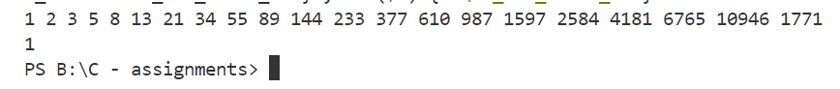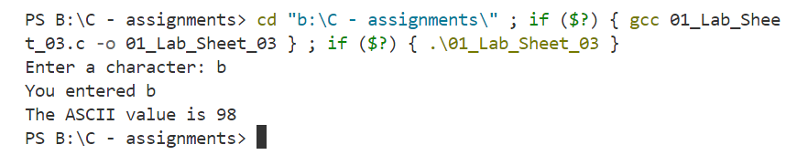

46

44

45

